CRICKET DATABASE MANAGEMENT SYSTEM

A PROJECT REPORT
Submitted by

CHILLA GNANESWAR REDDY[RA2311030010127] ANKINAPALLI VARUN BALAJI[RA2311030010126]
Under the Guidance of

Dr. SAFA
Designation, Department of Computing Technologies

in partial fulfillment of the requirements for the degree of

BACHELOR OF TECHNOLOGY
in
COMPUTER SCIENCE AND ENGINEERING



DEPARTMENT OF COMPUTING TECHNOLOGIES COLLEGE OF ENGINEERING AND TECHNOLOGY SRM INSTITUTE OF SCIENCE AND TECHNOLOGY KATTANKULATHUR– 603 203

MAY 2025


SRM INSTITUTE OF SCIENCE AND TECHNOLOGY KATTANKULATHUR–603 203

BONAFIDE CERTIFICATE

RA2311030010126& RA2311030010127 Certified to be the bonafide work done by VARUN BALAJI & GNANESWAR REDDYof II year/IV sem B.Tech Degree
Course in the Project Course – 21CSC205P Database Management Systems
in SRM INSTITUTE OF SCIENCE AND TECHNOLOGY, Kattankulathur
for the academic year 2023-2024.

Date: 17/03/2025

Faculty in Charge HEAD OF THE DEPARTMENT
Dr.T.S.Shiny Angel Dr.Annie Uthra
Associate Professor Head of the Department
Department of Computational Department of Computational
Intelligence Intelligence
SRMSIT SRMSIT
Kattankulathur Kattankulathur

ABSTRACT

Cricket Database Management System is a software application to manage all the activities concern to the cricket. This project will help the cricket organization to store all cricketrelated information. This application is useful store all the information related to the players, teams, matches, score and stadium ground, etc., Cricket Database Management is a cricket scheduling- based application exclusively for the game of cricket. The Application features schedules, information about teams, records of batting and bowling, creating new schedules, can search about players. The admin has all authorities to make changes for the database so admin can add players, can add schedules, can add stadiums, can add scores and also have permission to removing of them from the database. It features with printing the details of player, Teams, Matches, Scores, Stadium. It can fetch the schedules with their venue and squad available by the team, players selected for the current match. The admin has authorizedto perform all CRUD operation on the database. The main objective of the application is to automate the existing method of managing data manually to systematic storage of data, whichcan be searched any time as and when required. The other main objective of this applicationis to store all the player, teams, match, ground details

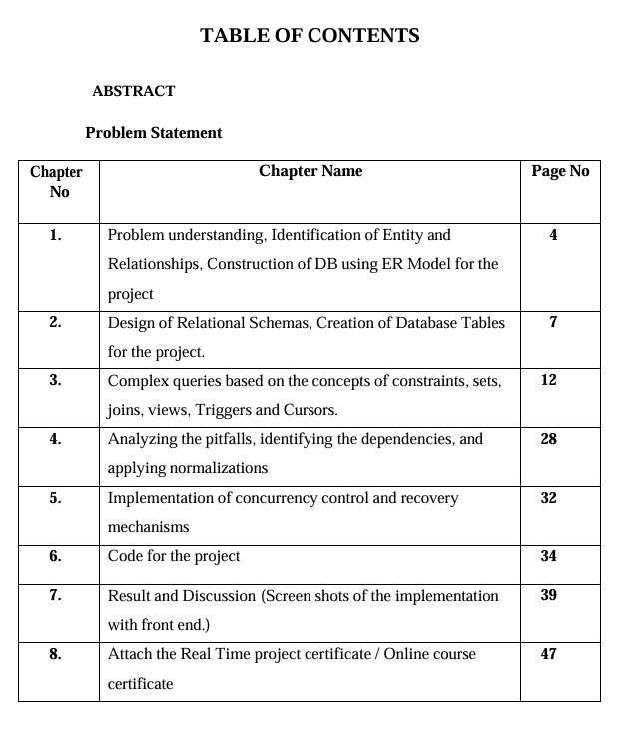

PROBLEM STATEMENT
The Cricket Database Management System (CDMS) streamlines cricket data management, addressing inefficiencies in manual processes. It centralizes player profiles, match schedules, and statistical records for easy access. Data integrity is ensured through robust validation mechanisms. Real-time updates keep stakeholders informed of match scores and player performances. Powerful analytics tools enable informed decision-making by coaches and administrators. Scalability ensures the system can accommodate future growth without performance issues. Integration with live scoring platforms and social media enhances the cricket experience. Customization options cater to the specific needs of different cricket organizations and stakeholders. Overall, the CDMS enhances efficiency, transparency, and competitiveness in cricket management.

CHAPTER 1

Problem understanding, Identification of Entity and Relationships, Construction of DB using ER Model for the project

For a Cricket Database Management System (CDMS), comprehending the intricacies of cricket management, identifying pertinent entities, and delineating their relationships is paramount prior to constructing a database employing an Entity-Relationship (ER) model.

Problem Understanding:
- Cricket management encompasses a multitude of tasks including player profiles, match scheduling, statistical analysis, and administrative functions.
- The objective is to devise a system that automates these operations, boosting efficacy, and augmenting the overall cricketing experience.

Identification Of ER:
An entity relationship model, also called an entity-relationship (ER) diagram, is a graphical representation of entities and their relationships to each other, typically used in computing in regard to the organization of data within databases or information systems. An entity is a piece of data-an object or concept about which data is stored.
The cardinality or fundamental principle of one data aspect with respect to another is a critical feature. The relationship of one to the other must be precise and exact between each other in order to explain how each aspect links together. In simple words Cardinality is a way to define the relationship between two entities.

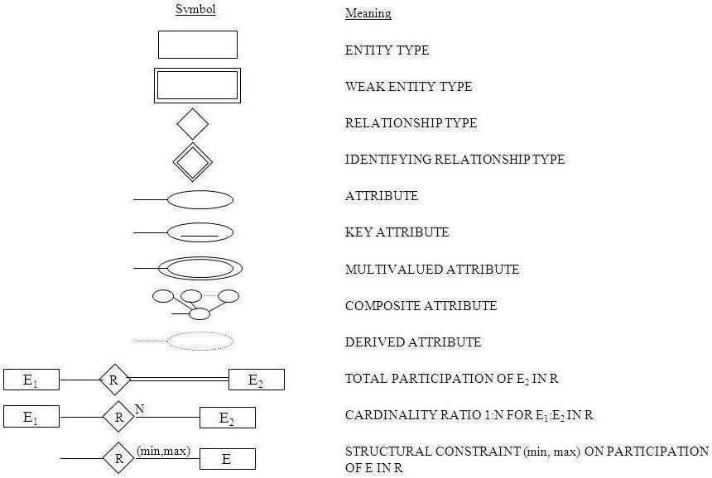
Figure 1.1 Notation for ER Diagram

Cardinalities can denote that an entity is optional (for example, an employee rep could have no customers or could have many) or mandatory (for example, there must be at least one product listed in an order.
The four main cardinal relationships are:
- One-to-one (1: 1) - For example, each customer in a database is associated with one mailing address.
- One-to-many (1: N) - For example, a single customer might place an order for multiple products. The customer is associated with multiple entities, but all those entities have a single connection back to the same customer.
- Many-to-one (N: 1) – For example, many employees will have only one manager above them but one manager can have many employees below him.

- Many-to-many (M: N) - For example, at a company where all call center agents work with multiple customers, each agent is associated with multiple customers, and multiple customers might also be associated with multiple agents.
- 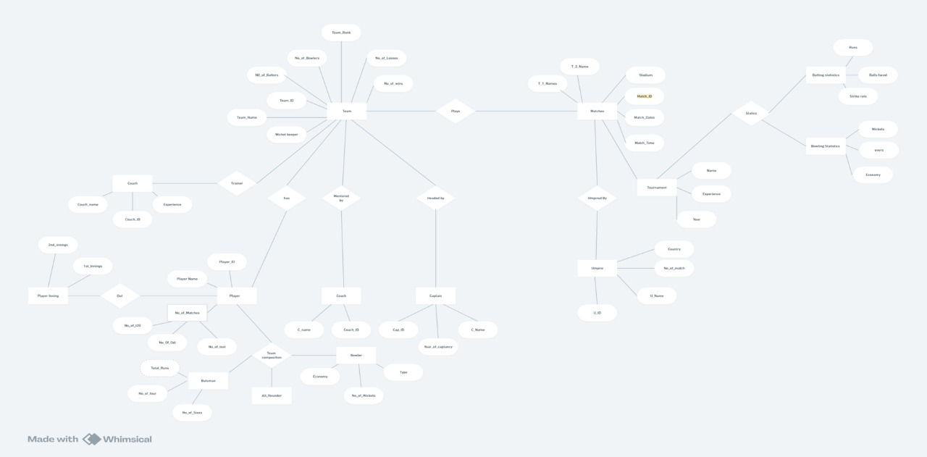

Figure 1.2 Construction Of ER-Diagram For Project

CHAPTER 2

Design of Relational Schemas, Creation of Database Tables for the project. Design of Relational Schemas:
A database schema is the skeleton structure that represents the logical view of the entire database. It defines how the data is organized and how the relations among them are associated. It formulates all the constraints that are to be applied on the data. A database schema defines its entities and the relationship among them. It contains a descriptive detail ofthe database, which can be depicted by means of schema diagrams. It's the database designerswho design the schema to help programmers understand the database and make it useful. It is important that we distinguish these two terms individually. Database schema is the skeletonof database. It is designed when the database doesn't exist at all. Once the database is operational, it is very difficult to make any changes to it. A database schema does not contain any data or information. A database instance is a state of operational database with data atany given time. It contains a snapshot of the database. Database instances tend to change withtime.
A DBMS ensures that its every instance (state) is in a valid state, by diligently following all the validations, constraints, and conditions that the database designers have imposed. A database schema can be divided broadly into two categories:
- Physical Database Schema - This schema pertains to the actual storage of data and itsform of storage like files. indices, etc. It defines how the data will be stored in a secondary storage.
- Logical Database Schema – This schema defines all the logical constraints that needto be applied on the data stored. It defines tables, views and integrity constraints.

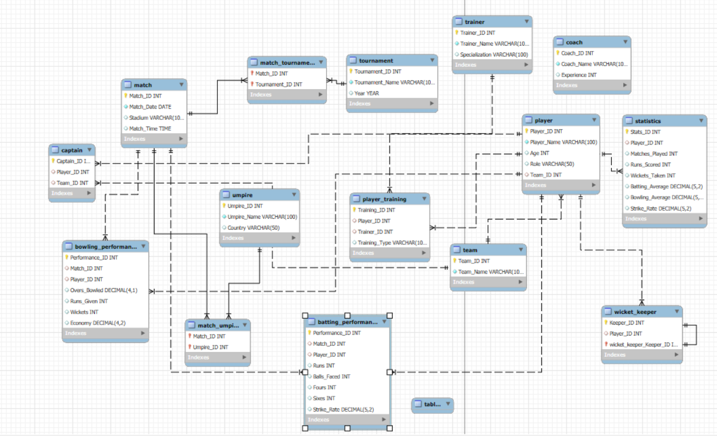

Figure 2.1 Schema diagram

CREATION OF DATABASES:

Team Table:
create table team(
team_id int primary key, team_name varchar(255) unique
);
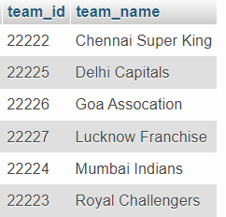

Player Table:
create table player(
player_id int primary key,name varchar(255),
address varchar(255) not null,phone_no int,
dob date, role varchar(20), since date, salary int, team_id int,
foreign key(team_id) references team(team_id) on delete set null
);
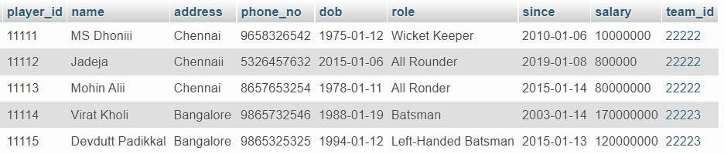

Stadium Table:
create table stadium(
stadium_id int primary key, stadium_name varchar(255) not null,stadium_location varchar(255), capacity int
);

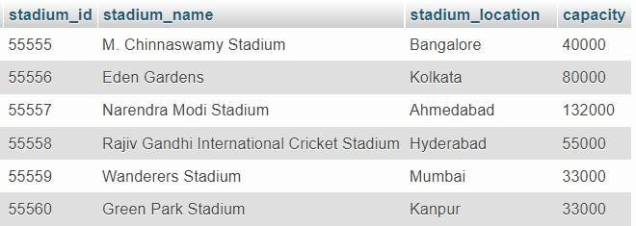

Matches Table:
create table matches(
match_id int primary key,team1_id int not null, team2_id int not null, match_date date, stadium_id int,
foreign key(stadium_id) references stadium(stadium_id) on delete set null
);
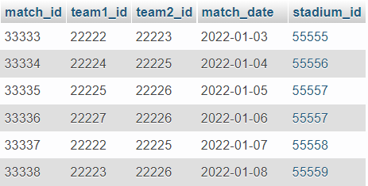

Scores Table:
create table scores(
match_id int, team_id int
primary key(match_id, team_id),scores int,
result varchar(20) not null,

foreign key(match_id) references matches(match_id) on delete cascade,foreign key(team_id) references team(team_id) on delete cascade
);
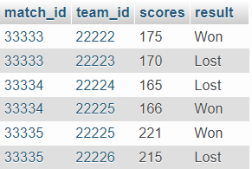

CHAPTER 3

Complex queries based on the concepts of constraints, sets, joins, views, Triggers and Cursors.
CREATE TRIGGER update_team_rank AFTER INSERT ON matches FOR EACH ROW
BEGIN
UPDATE teams
SET team_rank = CASE
WHEN teams.team_name = NEW.winning_team THEN team_rank - 1 WHEN teams.team_name = NEW.losing_team THEN team_rank + 1 ELSE team_rank
END; END;

CREATE PROCEDURE calculate_average_batting_stats() BEGIN
DECLARE done INT DEFAULT 0;
DECLARE player_id INT; DECLARE total_runs INT; DECLARE total_matches INT;
DECLARE avg_runs DECIMAL(10, 2);
DECLARE player_cursor CURSOR FOR SELECT play_id FROM players; DECLARE CONTINUE HANDLER FOR NOT FOUND SET done = 1;
OPEN player_cursor; player_loop: LOOP
FETCH player_cursor INTO player_id;
IF done THEN LEAVE player_loop; END IF;
SELECT SUM(runs_scored), COUNT(*) INTO total_runs, total_matches FROM batting_stats WHERE player_id = player_id;
IF total_matches > 0 THEN SET avg_runs = total_runs / total_matches; ELSE SET avg_runs = 0; END IF;
END LOOP;
CLOSE player_cursor; END;

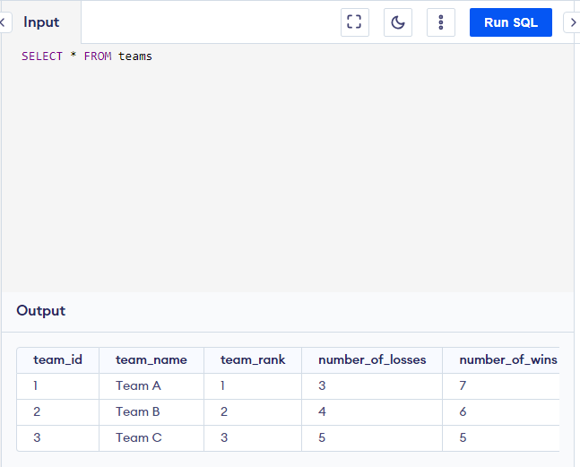
CREATE TABLE teams (
1
team_id INT PRIMARY KEY,
team_name VARCHAR(255) NOT NULL, team_rank INT,
number_of_losses INT, number_of_wins INT, number_of_bowlers INT, number_of_batters INT, wicket_keeper VARCHAR(255)
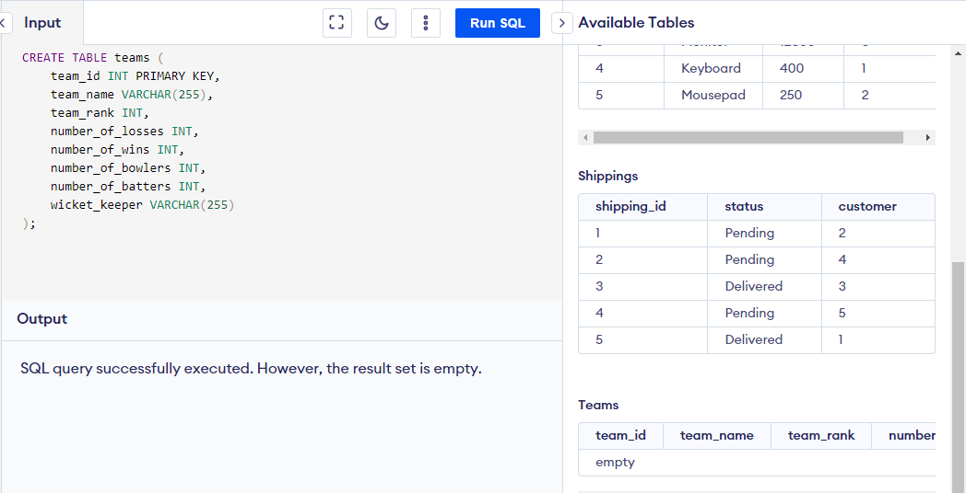
);
INSERT INTO teams (team_id, team_name, team_rank, number_of_losses, number_of_wins, number_of_bowlers, number_of_batters, wicket_keeper)
VALUES
(1, 'Team A', 1, 3, 7, 5, 6, 'Player1'),
(2, 'Team B', 2, 4, 6, 4, 7, 'Player2'),
(3, 'Team C', 3, 5, 5, 5, 8, 'Player3');
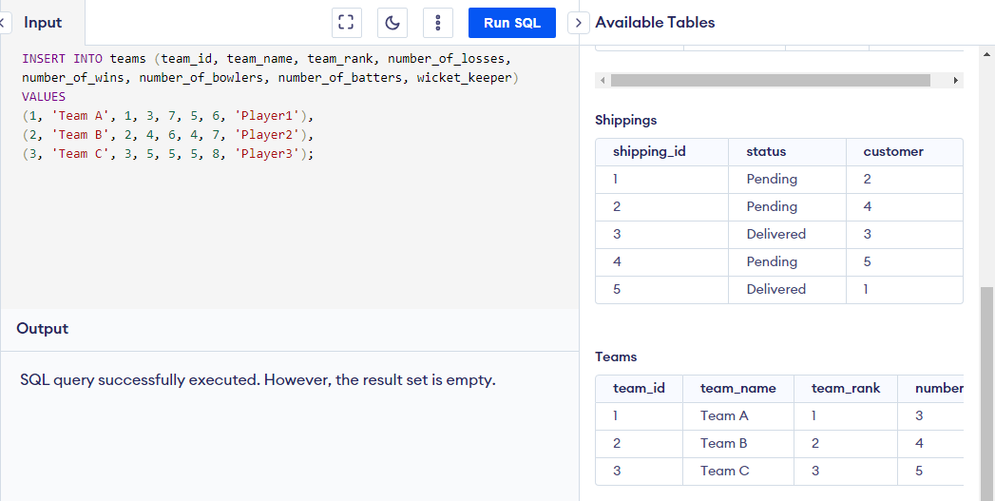

SELECT * FROM teams

SELECT *
FROM teams
WHERE wicket_keeper LIKE 'Player%';
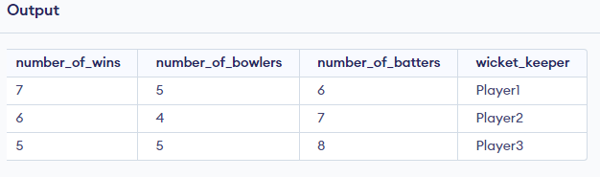
SELECT *
FROM teams
WHERE wicket_keeper IN (SELECT DISTINCT wicket_keeper FROM teams WHERE number_of_bowlers > 0);

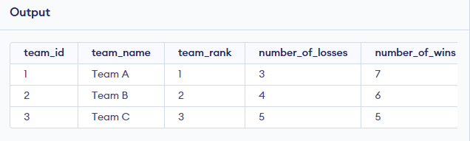

SELECT AVG(number_of_losses) AS avg_losses FROM teams;
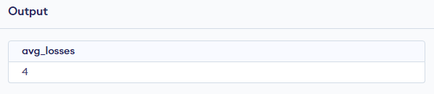
SELECT *
FROM teams
WHERE team_rank IN (1, 2, 3)
AND number_of_wins BETWEEN 6 AND 7;
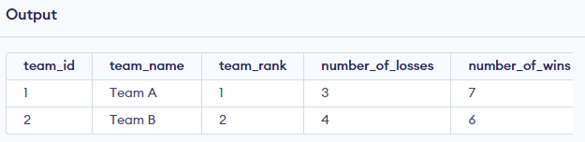
CREATE TABLE matches ( match_id INT PRIMARY KEY, test_one_name VARCHAR(255), test_two_name VARCHAR(255), stadium VARCHAR(255), match_date DATE,
match_time TIME
);

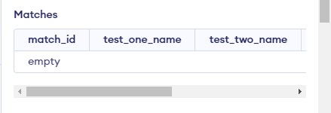

INSERT INTO matches (match_id, test_one_name, test_two_name, stadium, match_date, match_time) VALUES
(1, 'Team A', 'Team B', 'Stadium X', '2024-03-28', '10:00:00'),
(2, 'Team C', 'Team D', 'Stadium Y', '2024-03-29', '11:30:00'),
(3, 'Team E', 'Team F', 'Stadium Z', '2024-03-30', '09:00:00');

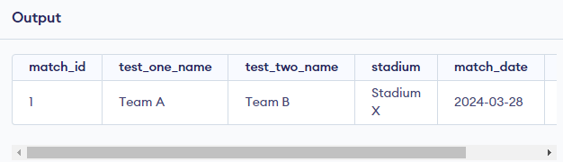

SELECT * FROM matches ORDER BY match_date DESC;
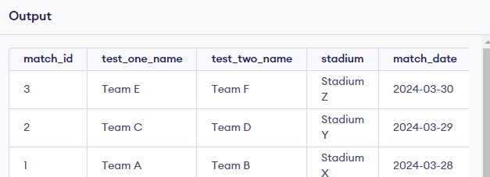

SELECT * FROM matches WHERE match_date > '2024-03-28';
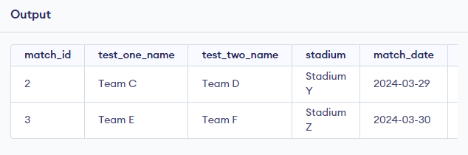
DELETE FROM teams WHERE team_id = 2;
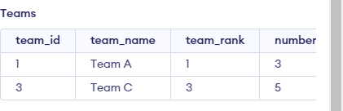

SELECT test_one_name AS team_name, COUNT(*) AS num_matches FROM matches

GROUP BY test_one_name UNION ALL
SELECT test_two_name AS team_name, COUNT(*) AS num_matches FROM matches
GROUP BY test_two_name;
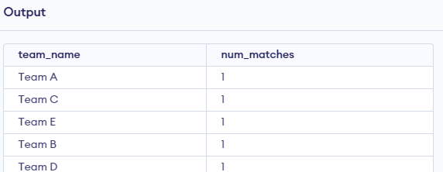
CREATE TABLE players ( play_id INT PRIMARY KEY,
player_name VARCHAR(255) DEFAULT 0, number_of_matches INT, number_of_T20_matches INT DEFAULT 0, number_of_ODI_matches INT, number_of_test_matches INT
);
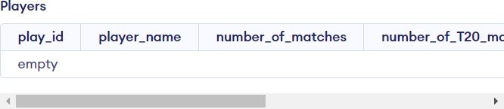

INSERT INTO players (play_id, player_name, number_of_matches, number_of_T20_matches, number_of_ODI_matches, number_of_test_matches)
VALUES
(1, 'Player 1', 75, 20, 40, 15),
(2, 'Player 2', 100, 30, 50, 20),
(3, 'Player 3', 50, 10, 30, 10),
(4, 'Player 4', 80, 25, 45, 10),
(5, 'Player 5', 120, 40, 60, 20);
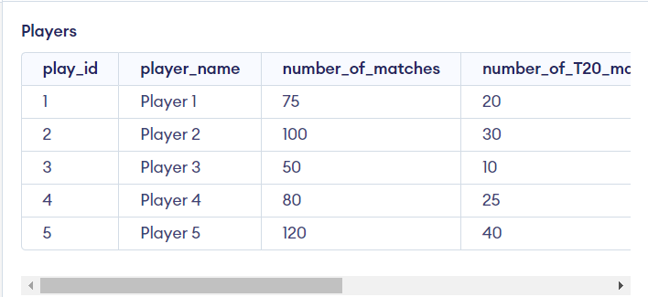

SELECT * FROM players ORDER BY number_of_matches DESC LIMIT 1;
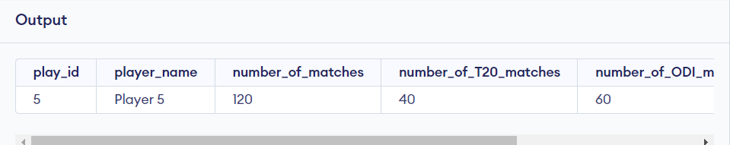
UPDATE players
SET number_of_matches = 500 WHERE play_id = 1;

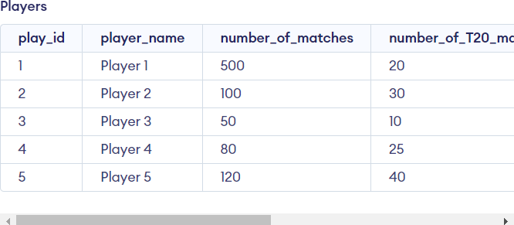
DELETE FROM players WHERE play_id = 3;
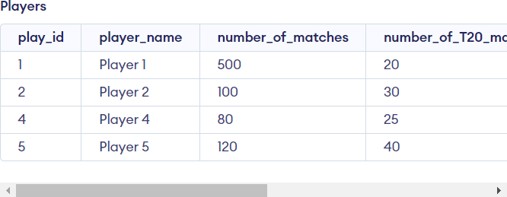
ALTER TABLE players
DROP COLUMN number_of_T20_matches;
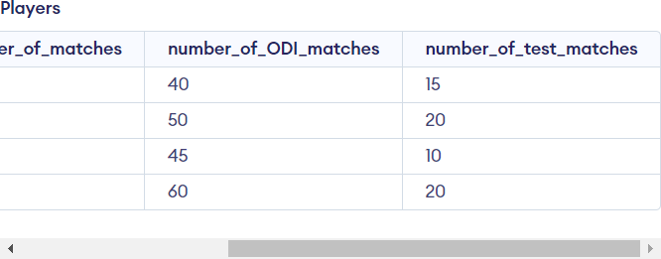

CREATE TABLE coach (
coach_id INT PRIMARY KEY, coach_name VARCHAR(255), kochadi VARCHAR(255)
);

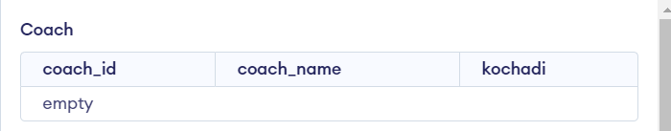
INSERT INTO coach (coach_id,coach_name, kochadi) VALUES
(1,'Coach 1', 'Kochadi 1'),
(2,'Coach 2', 'Kochadi 2'),
(3,'Coach 3', 'Kochadi 3'),
(4,'Coach 4', 'Kochadi 4'),
(5,'Coach 5', 'Kochadi 5');
17
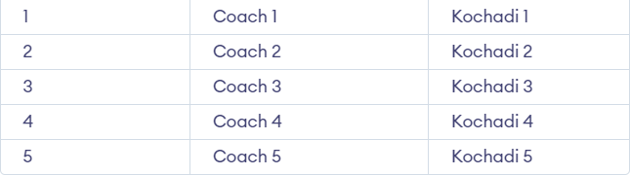

INSERT INTO coach (coach_id,coach_name, kochadi) VALUES (6,'New Coach', 'New Kochadi');
ALTER TABLE coach
ADD unique_coach_name VARCHAR;
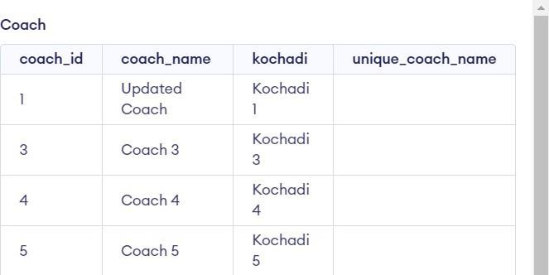
CREATE VIEW coach_details AS SELECT coach_name, kochadi FROM coach;

SELECT * FROM coach_view
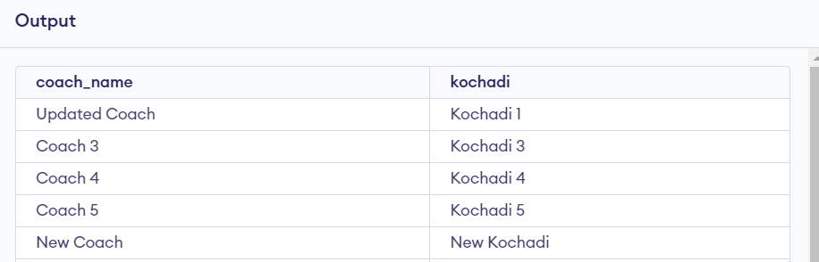
CREATE VIEW coaches_from_kochadi AS SELECT coach_name
FROM coach
WHERE kochadi = 'Kochadi 1';
SELECT * FROM coaches_from_kochadi

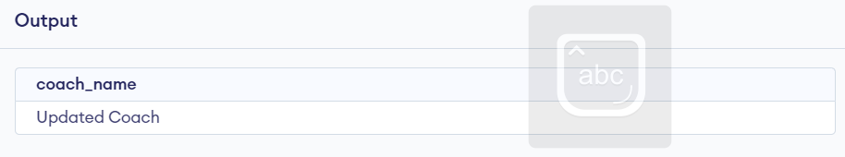

CREATE TABLE captain ( captain_id INT PRIMARY KEY, captain_name VARCHAR(255), year_of_captaincy INT
);
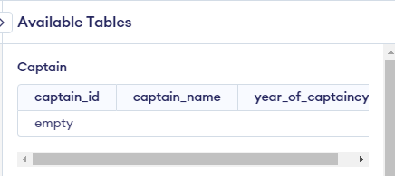

INSERT INTO captain (captain_id, captain_name, year_of_captaincy) VALUES
(1, 'Captain 1', 2018),
(2, 'Captain 2', 2019),
(3, 'Captain 3', 2020),
(4, 'Captain 4', 2021),
(5, 'Captain 5', 2022);
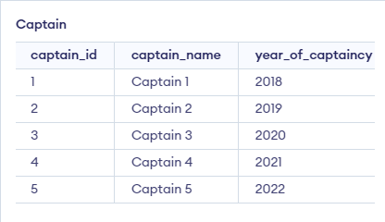

DELETE FROM captain WHERE captain_id = 2;
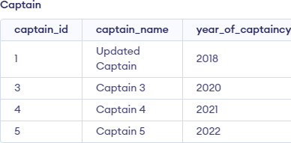

SELECT name_of_captain FROM captain
WHERE year_of_captaincy IN ( SELECT MAX(year_of_captaincy) FROM captain
);
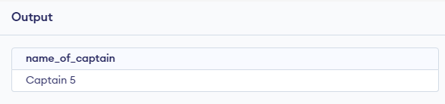

DROP TABLE Captain
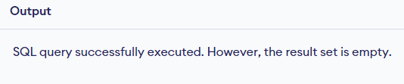
CREATE TABLE umpire ( umpire_id INT PRIMARY KEY, umpire_name VARCHAR(255), number_of_matches INT, country VARCHAR(255)
);
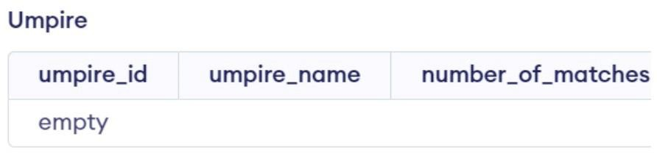

INSERT INTO umpire (umpire_id, umpire_name, number_of_matches, country) VALUES
(1, 'Umpire 1', 50, 'Australia'),
(2, 'Umpire 2', 60, 'England'),
(3, 'Umpire 3', 40, 'India'),
(4, 'Umpire 4', 55, 'South Africa'),
(5, 'Umpire 5', 45, 'New Zealand');
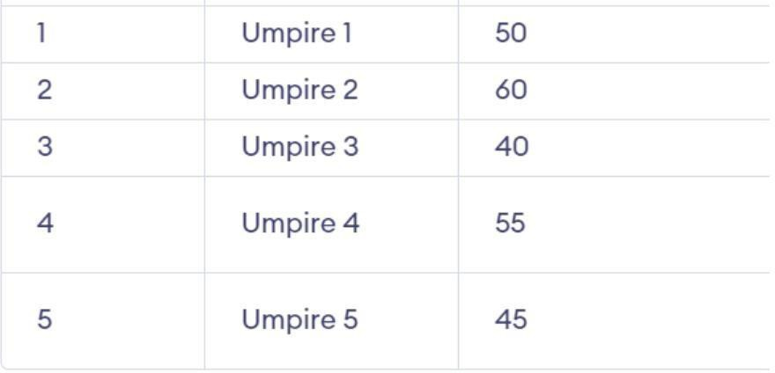

SELECT umpire_name FROM umpire
WHERE number_of_matches > ( SELECT AVG(number_of_matches) FROM umpire
);

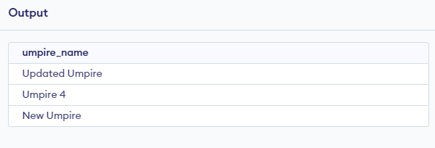

DROP TABLE umpire
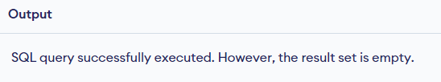

CREATE TABLE batsman (
batsman_id INT NOT NULL UNIQUE, batsman_name VARCHAR(255) NOT NULL, total_runs INT,
number_of_fours INT, number_of_sixes INT
);
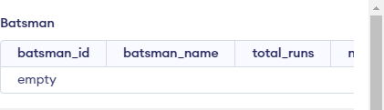
INSERT INTO batsman (batsman_id, batsman_name, total_runs, number_of_fours, number_of_sixes) VALUES
(1, 'Batsman 1', 5000, 600, 150),
(2, 'Batsman 2', 4500, 550, 120),
(3, 'Batsman 3', 6000, 700, 200),
(4, 'Batsman 4', 3500, 400, 100),
(5, 'Batsman 5', 7000, 800, 250);
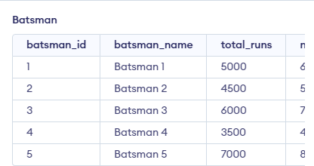

SELECT batsman_name, SUM(number_of_fours) AS total_fours FROM batsman
GROUP BY batsman_name HAVING total_fours > 500;
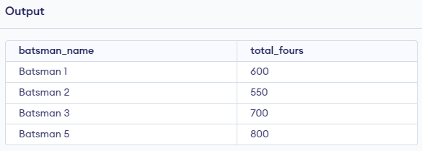

SELECT batsman_name, total_runs, CASE
WHEN total_runs >= 6000 THEN 'High Scorer' WHEN total_runs >= 4000 THEN 'Moderate Scorer' ELSE 'Low Scorer'
END AS scorer_category FROM batsman
ORDER BY total_runs DESC;
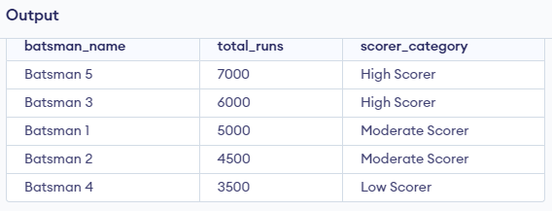

GRANT SELECT ON batsman TO username;
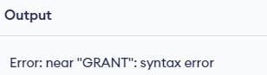

REVOKE SELECT ON batsman FROM username;

CREATE TABLE bowler (
bowler_id INT PRIMARY KEY DEFAULT = 0,
number_of_wickets INT, economy FLOAT,
type VARCHAR(255)

);
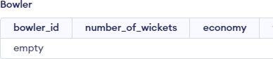

INSERT INTO bowler (bowler_id, number_of_wickets, economy, type) VALUES
(1, 500, 4.50, 'Spinner'),
(2, 450, 5.20, 'Fast Bowler'),
(3, 600, 4.80, 'Medium Pacer'),
(4, 350, 5.00, 'Spinner'),
(5, 700, 4.70, 'Fast Bowler');

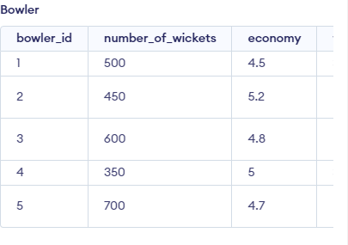

SELECT SUM(number_of_wickets) AS total_wickets FROM bowler;
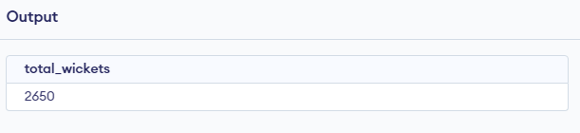

SELECT AVG(economy) AS average_economy FROM bowler;
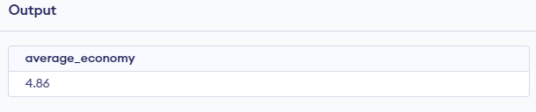

SELECT MAX(number_of_wickets) AS max_wickets FROM bowler;
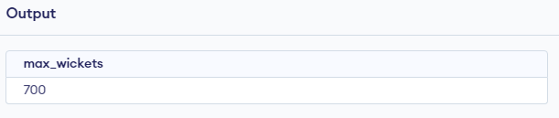

SELECT MIN(economy) AS min_economy FROM bowler;

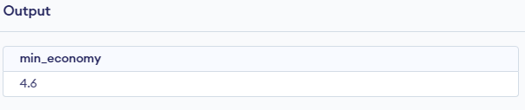

TEAMS AND MATCHES:
SELECT *
FROM teams
INNER JOIN matches ON teams.team_name = matches.test_one_name OR teams.team_name = matches.test_two_name;
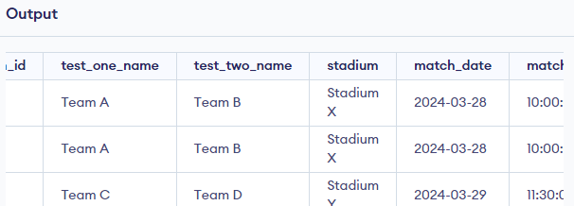
SELECT *
FROM teams
LEFT JOIN matches ON teams.team_name = matches.test_one_name OR teams.team_name = matches.test_two_name;
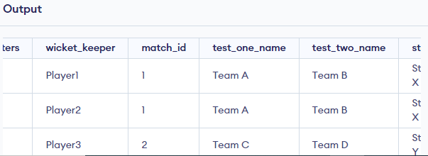
SELECT *
FROM teams
RIGHT JOIN matches ON teams.team_name = matches.test_one_name OR teams.team_name = matches.test_two_name;
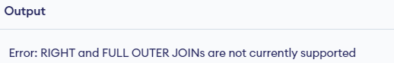

COACH:
SELECT *
FROM teams NATURAL JOIN coach;
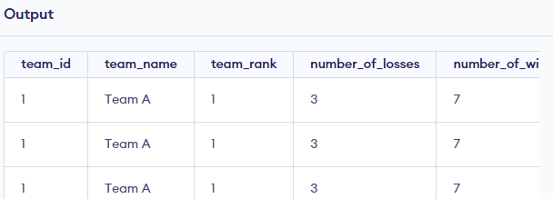

BATSMAN AND BOWLER:
SELECT b.batsman_name, b.total_runs, bo.number_of_wickets FROM batsman b
INNER JOIN bowler bo ON b.batsman_id = bo.bowler_id;
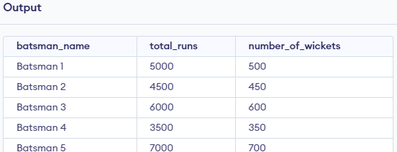

SELECT SUM(total_runs) AS total_runs_scored, SUM(number_of_wickets) AS total_wickets_taken FROM (
SELECT b.total_runs, bo.number_of_wickets FROM batsman b
INNER JOIN bowler bo ON b.batsman_id = bo.bowler_id
) AS combined_data;
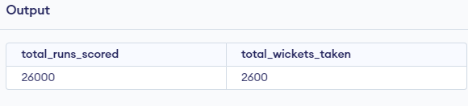
SELECT b.batsman_name, b.number_of_fours FROM batsman b
ORDER BY b.number_of_fours DESC LIMIT 1;
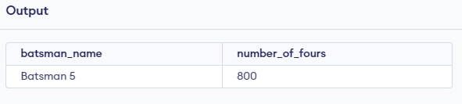

TEAMS AND COACH:
SELECT t.team_name, t.team_rank, c.coach_name FROM teams t
INNER JOIN coach c ON t.team_id = c.coach_id;
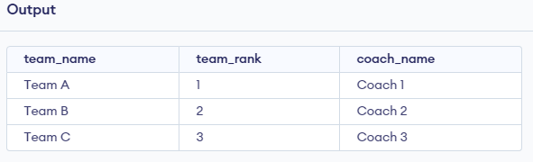

SELECT COUNT(*) AS total_teams, AVG(team_rank) AS average_team_rank FROM (
SELECT t.team_id, t.team_name, t.team_rank, c.coach_name FROM teams t
INNER JOIN coach c ON t.team_id = c.coach_id
) AS combined_data;
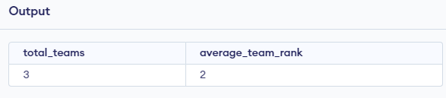

CAPTAIN AND COACH:
SELECT captain.captain_name, captain.year_of_captaincy, coach.coach_name, coach.kochadi FROM captain
CROSS JOIN coach;
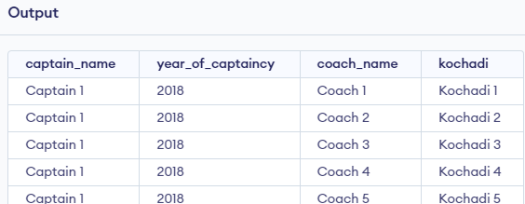
SELECT captain.captain_name, captain.year_of_captaincy, coach.coach_name, coach.kochadi FROM captain
LEFT JOIN coach ON captain.captain_name = coach.coach_name;
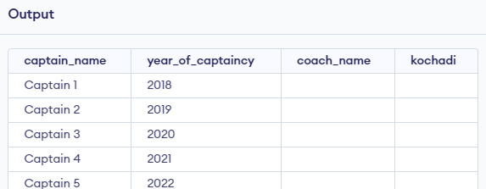
TEAM AND MATCHES:
SELECT matches.match_id, matches.stadium, matches.match_date, matches.match_time, teams.team_name AS team_one, teams_2.team_name AS team_two
FROM matches
INNER JOIN teams ON matches.test_one_name = teams.team_name
INNER JOIN teams AS teams_2 ON matches.test_two_name = teams_2.team_name;

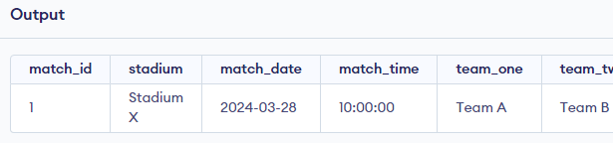

CREATE VIEW match_teams_view AS
SELECT matches.match_id, matches.stadium, matches.match_date, matches.match_time, teams.team_name AS team_one, teams_2.team_name AS team_two
FROM matches
INNER JOIN teams ON matches.test_one_name = teams.team_name
INNER JOIN teams AS teams_2 ON matches.test_two_name = teams_2.team_name; SELECT * FROM match_teams_view;

CREATE VIEW team_total_matches AS SELECT team_name,
(SELECT COUNT(*) FROM matches WHERE test_one_name = teams.team_name OR test_two_name = teams.team_name) AS total_matches
FROM teams;
SELECT * FROM team_total_matches;

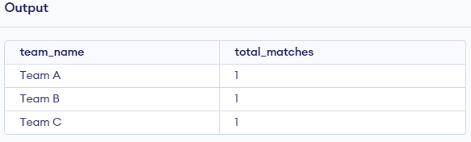
TEAMS, PLAYERS, MATCHES:
SELECT teams.team_name, COUNT(players.play_id) AS total_players, COUNT(matches.match_id) AS total_matches
FROM teams
JOIN players ON teams.team_id = players.play_id
JOIN matches ON teams.team_name = matches.test_one_name OR teams.team_name = matches.test_two_name
GROUP BY teams.team_name LIMIT 2;

CHAPTER – 4

Analyzing the pitfalls, identifying the dependencies, and applying normalizations
- Analyzing Pitfalls:

  - Data Anomalies: Without proper organization, anomalies like inserting incomplete match data, deleting player details accidentally, or updating match scores incorrectly can occur.
  - Poor Performance: Inefficient queries due to poorly designed database structures may result in slow retrieval of player statistics, match results, or team rankings.
  - Lack of Data Integrity: Without constraints, the CDMS may contain invalid player records, inconsistent match information, or inaccurate team rankings.

Identifying Dependencies:

  - Functional Dependencies: Determine relationships where attributes like player ID uniquely determine player details, and match ID determines match outcomes.
  - Transitive Dependencies: Identify dependencies where attributes like team ID determine player performance indirectly through match results.
  - Multi-valued Dependencies: Recognize relationships where a set of attributes like player skills determines multiple values in another set like player rankings.
  - Composite Dependencies: Identify dependencies involving combinations of attributes, such as team performance influenced by player skills and match conditions.

Normalization Table:
First Normal Form (1NF): This is the most basic level of normalization. In 1NF,each table cell should contain only a single value, and each column should have a uniquename.
The first normal form helps to eliminate duplicate data and simplify queries.
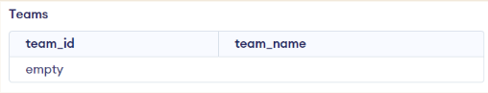
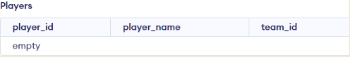

Second Normal Form (2NF): 2NF eliminates redundant data by requiring that each non-key attribute be dependent on the primary key. This means that each column should be directly related to the primary key, and not to other columns.
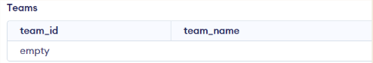
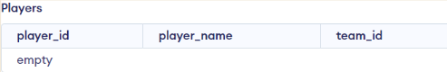
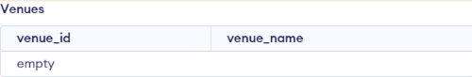

Third Normal Form (3NF): 3NF builds on 2NF by requiring that all non-key attributes are independent of each other. This means that each column should be directly related to the primary key, and not to any other columns in the same table.

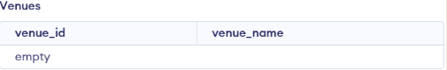

Boyce-Codd Normal Form (BCNF): BCNF requires that every non-trivial functional dependency in a table is a dependency on a super key. If any non-trivial functional dependencies exist on attributes that are not part of a candidate key, the table needs to be decomposed until it satisfies BCNF.

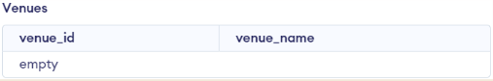
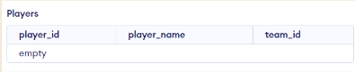
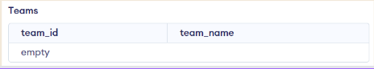

Fourth Normal Form (4NF): To achieve 4NF, we remove multi-valued dependencies.
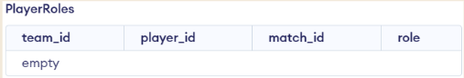

To normalize the PlayerRoles table to Fourth Normal Form (4NF), we need to decompose it further to eliminate the multi-valued dependencies. We'll create separate tables for each role a player can have in a match for a specific team.

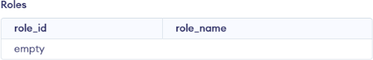

CHAPTER – 5

Implementation of concurrency control and recovery mechanisms

- Concurrency Control:
START TRANSACTION;
-- Insert data for player 1
INSERT INTO Players (player_id, player_name, team_id, age, role) VALUES (1, 'Virat Kohli', 1, 32, 'Batsman');
-- Insert data for player 2
INSERT INTO Players (player_id, player_name, team_id, age, role) VALUES (2, 'Rohit Sharma', 1, 34, 'Batsman');
-- Insert data for player 3
INSERT INTO Players (player_id, player_name, team_id, age, role) VALUES (3, 'Jasprit Bumrah', 1, 27, 'Bowler');
-- Insert data for player 4
INSERT INTO Players (player_id, player_name, team_id, age, role) VALUES (4, 'Steve Smith', 2, 32, 'Batsman');
-- Insert data for player 5
INSERT INTO Players (player_id, player_name, team_id, age, role) VALUES (5, 'David Warner', 2, 34, 'Batsman');
-- Commit the transaction COMMIT;

Recovery Mechanism:
START TRANSACTION;
-- Insert data for player 1
INSERT INTO Players (player_id, player_name, team_id, age, role) VALUES (1, 'Virat Kohli', 1, 32, 'Batsman');
-- Check if the insert was successful
SELECT ROW_COUNT() INTO @player1_inserted;
-- Insert data for player 2

INSERT INTO Players (player_id, player_name, team_id, age, role) VALUES (2, 'Rohit Sharma', 1, 34, 'Batsman');
-- Check if the insert was successful
SELECT ROW_COUNT() INTO @player2_inserted;
-- Insert data for player 3
INSERT INTO Players (player_id, player_name, team_id, age, role) VALUES (3, 'Jasprit Bumrah', 1, 27, 'Bowler');
-- Check if the insert was successful
SELECT ROW_COUNT() INTO @player3_inserted;
-- If any insert failed, rollback the transaction
IF (@player1_inserted = 0 OR @player2_inserted = 0 OR @player3_inserted = 0) THEN ROLLBACK;
ELSE
COMMIT; -- Otherwise, commit the transaction END IF;

CHAPTER 6

Code for the project

Login.java:
private void loginActionPerformed(java.awt.event.ActionEvent evt) {
if (username.getText().equals("admin") && password.getText().equals("pass")) { setVisible(false);
new Home().setVisible(true);
} else {
JOptionPane.showMessageDialog(null, "Incorrect Username or
Password");
}
}
private void exitActionPerformed(java.awt.event.ActionEvent evt) {
int a = JOptionPane.showConfirmDialog(null, "Do you want to close Application", "Select", JOptionPane.YES_NO_OPTION);
if (a == 0)
System.exit(0);
}
private void LogoutActionPerformed(java.awt.event.ActionEvent evt) {
int a = JOptionPane.showConfirmDialog(null, "Do you want to Logout", "Select", JOptionPane.YES_NO_OPTION);
if (a == 0) {
setVisible(false);
new Login().setVisible(true);
}
}

ConnectionProvider.java:
package CricketManagementSystem;import java.sql.Connection; import java.sql.DriverManager;
//Connect to the MySQL databasepublic class ConnectionProvider {

public static Connection getConnection() { try {
Class.forName("com.mysql.cj.jdbc.Driver"); Connection con =
DriverManager.getConnection("jdbc:mysql://localhost:3306/cricket_database", "root", ""); return con;
} catch (Exception e) {} return null;
}
}

AddUpdateDeletePlayer.java:
private void saveActionPerformed(java.awt.event.ActionEvent evt) {int playerid = Integer.parseInt(player_id.getText());
String playerName = player_name.getText();String addr = address.getText(); BigInteger phon = new BigInteger(phone.getText());
SimpleDateFormat dFormat = new SimpleDateFormat("yyyy-MM-dd");String birthDate = dFormat.format(dob.getDate());
String rol = role.getText();
String joiningDate = dFormat.format(joining_date.getDate());String sal = salary.getText();
String teamid = team_id.getText();try {
Connection con = ConnectionProvider.getConnection();Statement st = con.createStatement();
st.executeUpdate("insert into player values('" + playerid + "', '" + playerName + "','" + addr + "', '" + phon + "', '" + birthDate + "', '" + rol + "', '" + joiningDate + "', '" + sal + "','" + teamid + "')");
JOptionPane.showMessageDialog(this, "Successfully Saved");setVisible(false); new AddUpdateDeletePlayer().setVisible(true);
} catch (SQLException ex) { Logger.getLogger(AddUpdateDeletePlayer.class.getName()).log(Level.SE VE RE, null, ex);
}
}

private void updateActionPerformed(java.awt.event.ActionEvent evt) {int playerid = Integer.parseInt(player_id.getText());
String playerName = player_name.getText();String addr = address.getText(); BigInteger phon = new BigInteger(phone.getText());
SimpleDateFormat dFormat = new SimpleDateFormat("yyyy-MM-dd");String birthDate = dFormat.format(dob.getDate());
String rol = role.getText();
String joiningDate = dFormat.format(joining_date.getDate());String sal = salary.getText();
String teamid = team_id.getText();try {
Connection con = ConnectionProvider.getConnection();
//Query to insert data to student table
pst = con.prepareStatement("update player set name = ?, address = ? , phone_no =
?, dob = ?, role = ?, since = ?, salary= ?, team_id = ? where player_id = ?"); pst.setString(1, playerName);
pst.setString(2, addr);
pst.setBigDecimal(3, new BigDecimal(phon)); pst.setString(4, birthDate);
pst.setString(5, rol);
pst.setString(6, joiningDate); pst.setString(7, sal); pst.setString(8, teamid); pst.setInt(9, playerid); pst.executeUpdate();
JOptionPane.showMessageDialog(this, "Succesfully Updated");this.dispose(); new AddUpdateDeletePlayer().setVisible(true);
} catch (SQLException ex) { Logger.getLogger(AddUpdateDeletePlayer.class.getName()).log(Level.SE VE RE, null, ex);
}
}
private void deleteActionPerformed(java.awt.event.ActionEvent evt) {int playerid = Integer.parseInt(player_id.getText());
try {
Connection con = ConnectionProvider.getConnection();

PreparedStatement pst = con.prepareStatement("delete from player where player_id
= ?");
pst.setInt(1, playerid);pst.executeUpdate(); JOptionPane.showMessageDialog(this, "Succesfully Deleted"); this.dispose();
new AddUpdateDeletePlayer().setVisible(true);
} catch (SQLException ex) { Logger.getLogger(AddUpdateDeletePlayer.class.getName()).log(Level.SEVERE, null, ex);
}}

ShowPlayerDetails.java: PreparedStatement pst; ResultSet rs; DefaultTableModel d;
public void userLoad() { int count;
try {
Connection con = ConnectionProvider.getConnection(); pst = con.prepareStatement("select * from player");
rs = pst.executeQuery(); ResultSetMetaData rsd = rs.getMetaData(); count = rsd.getColumnCount();
d = (DefaultTableModel) tblPlayer.getModel();d.setRowCount(0); while (rs.next()) {
Vector v2 = new Vector();
for (int i = 1; i <= count; i++) { v2.add(rs.getString("player_id")); v2.add(rs.getString("name")); v2.add(rs.getString("address")); v2.add(rs.getString("phone_no")); v2.add(rs.getString("dob"));
v2.add(rs.getString("role"));

v2.add(rs.getString("since")); v2.add(rs.getString("salary")); v2.add(rs.getString("team_id"));
}
d.addRow(v2);
}
} catch (SQLException ex) { Logger.getLogger(ShowPlayerDetails.class.getName()).log(Level.SEVERE
, null, ex);
}
}

CHAPTER 7

Result and Discussion (Screen shots of the implementation with front end.)


Figure 7.1: Admin Login Page
It shows admin login page which gives authentication to enter into the Admin page

Figure 7.2: Home page

In the above Figure 7.2, shows which allows to add, update and delete of players, teams,matches, score, stadiums and about page.


Figure 7.3: Player menu
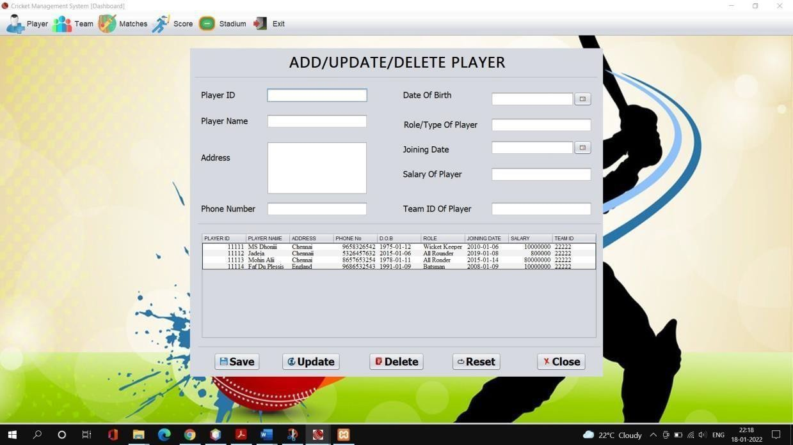

Figure 7.4 Add/ Update/ Delete player
In the above Figure 7.4, It show player window which allows admin to add, update and deletethe Player details

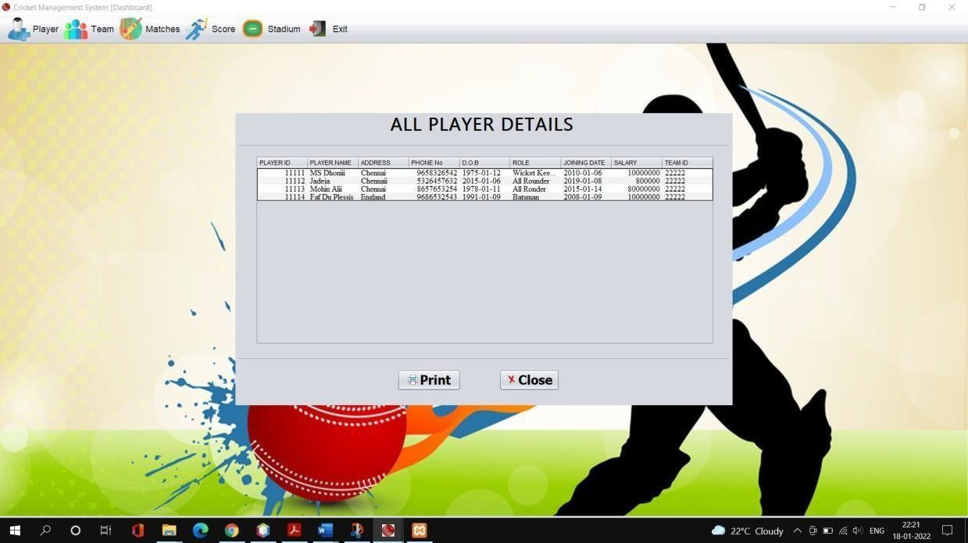

Figure 7.5 Player details

In the above Figure 7.5, It shows player details window which allows admin to print thedetails of player from the connected printer or just can save as pdf document.

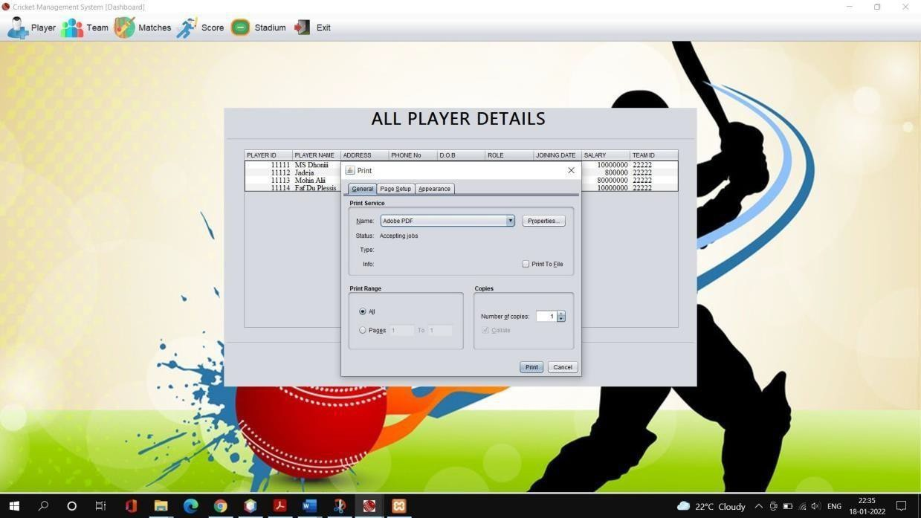
Figure 7.6 Print player details

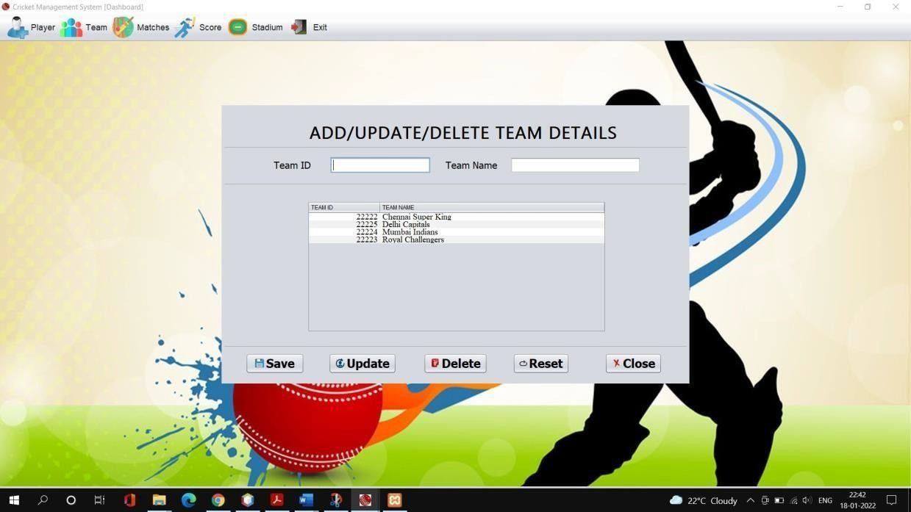

Figure 7.7 Add/ Update/ Delete Team
In the above Figure 7.7, It show team window which allows admin to add, update and deletethe team details
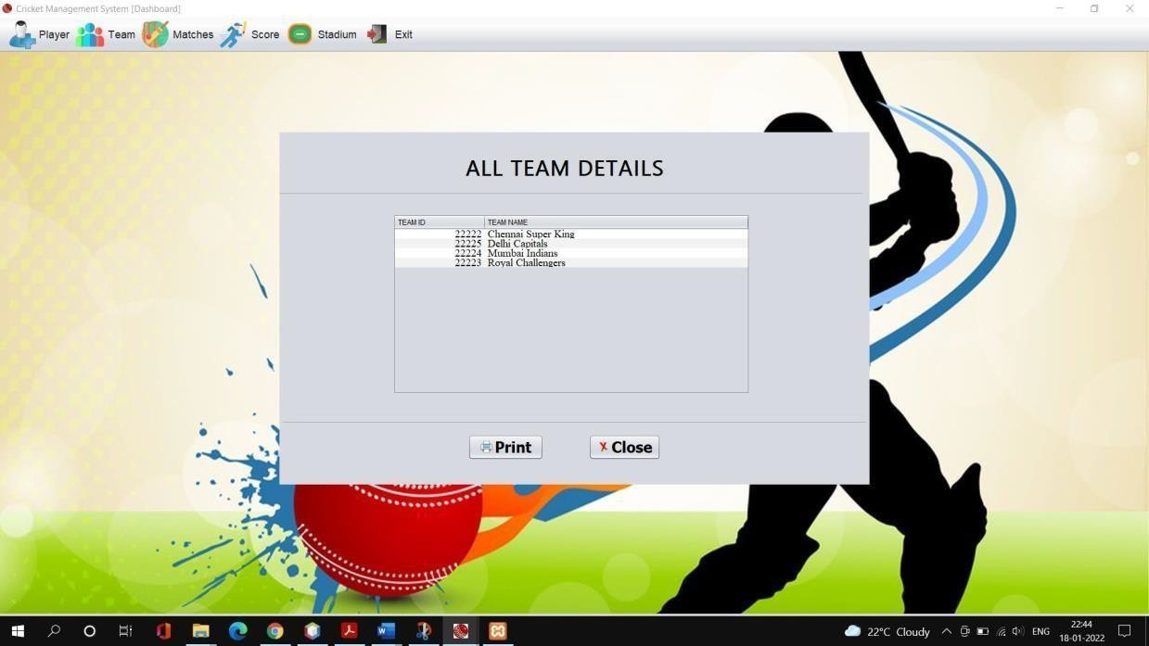
Figure 7.8 Team details
In the above Figure 7.8, It shows team details window which allows admin to print the detailsof team from the connected printer or just can save as pdf doc

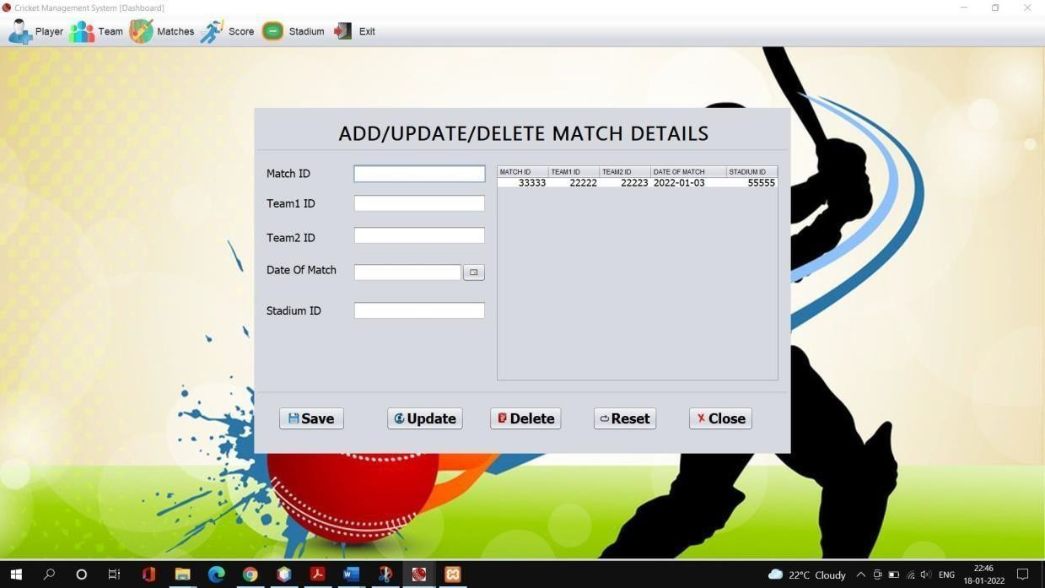
Figure 7.9 Add/ Update/ Delete match
In the above Figure 7.9, It shows match details window which allows admin to schedules thematches between the teams and also can update or delete a scheduled match.
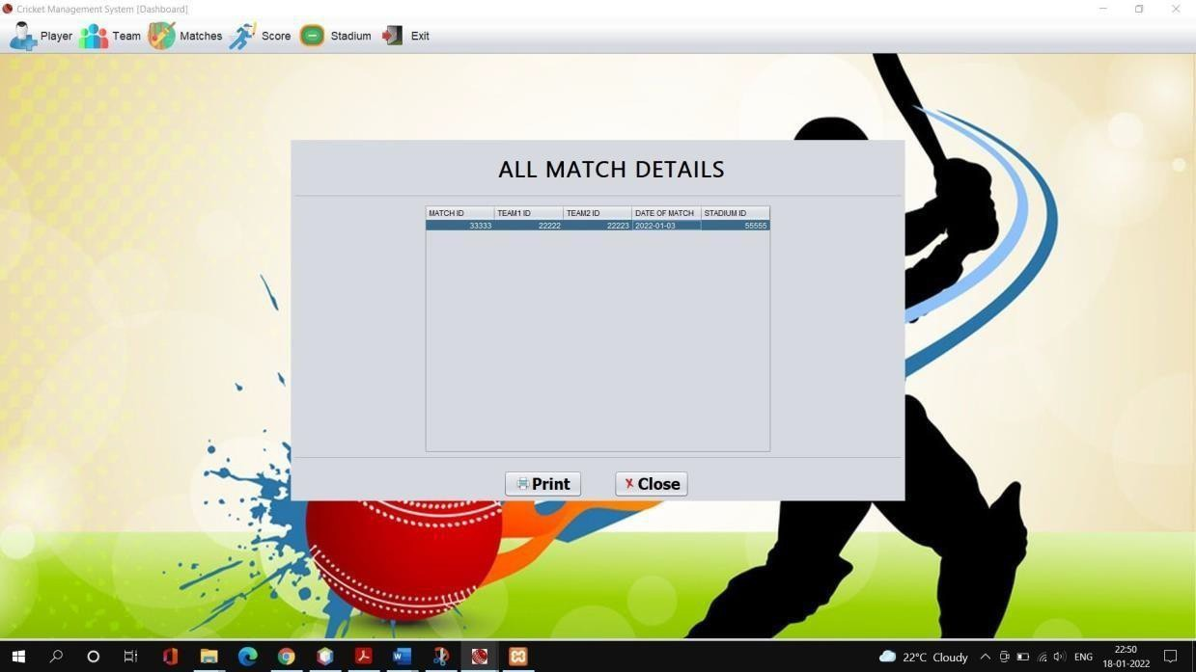
Figure 7.10 Match details
In the above Figure 7.10, It shows match details window which allows admin to print thedetails of match from the connected printer or just can save as pdf document.

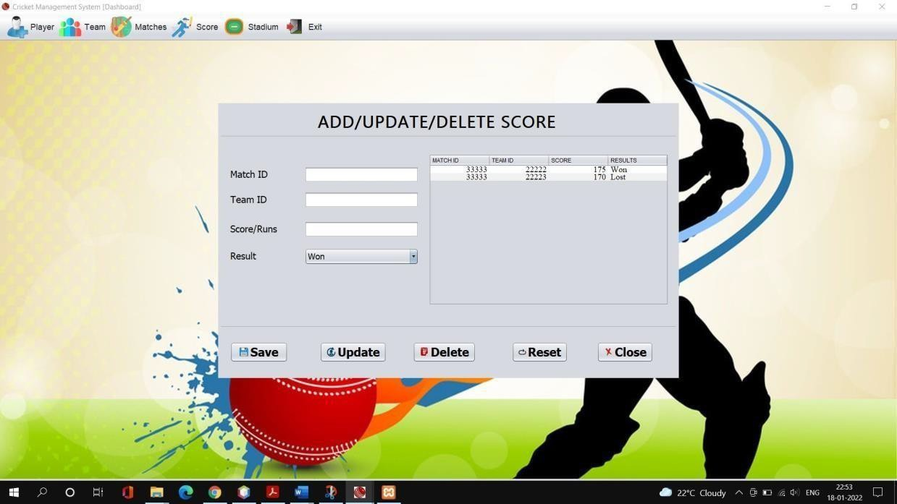

Figure 7.11 Add/ Update/ Delete score
In the above Figure 7.11, It shows score window which allows admin to add score of aparticular team and can also update or delete the score.
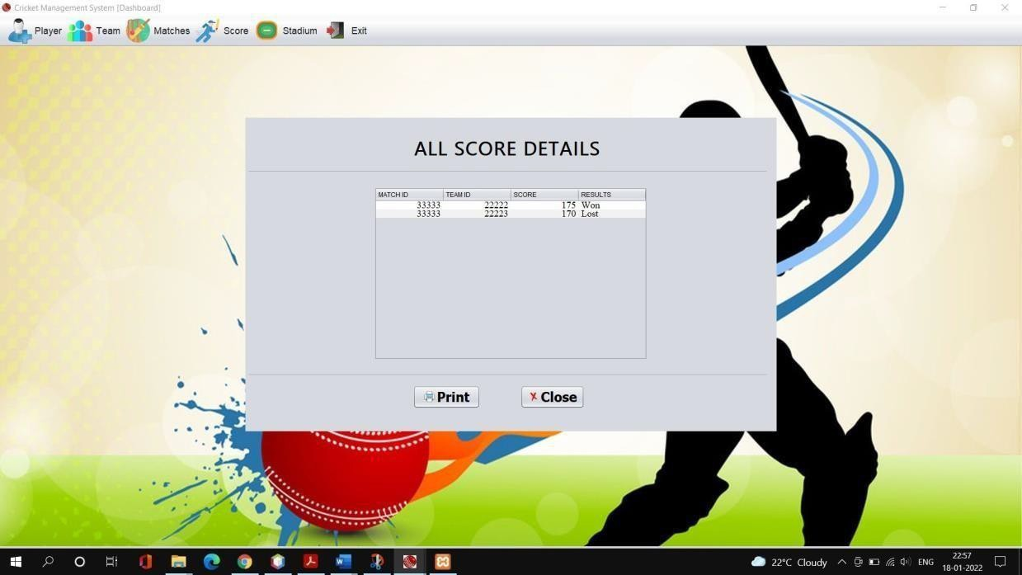
Figure 7.12 Score details
In the above Figure 7.12, It shows score details window which allows admin to print thedetails of score from the connected printer or just can save as pdf document.

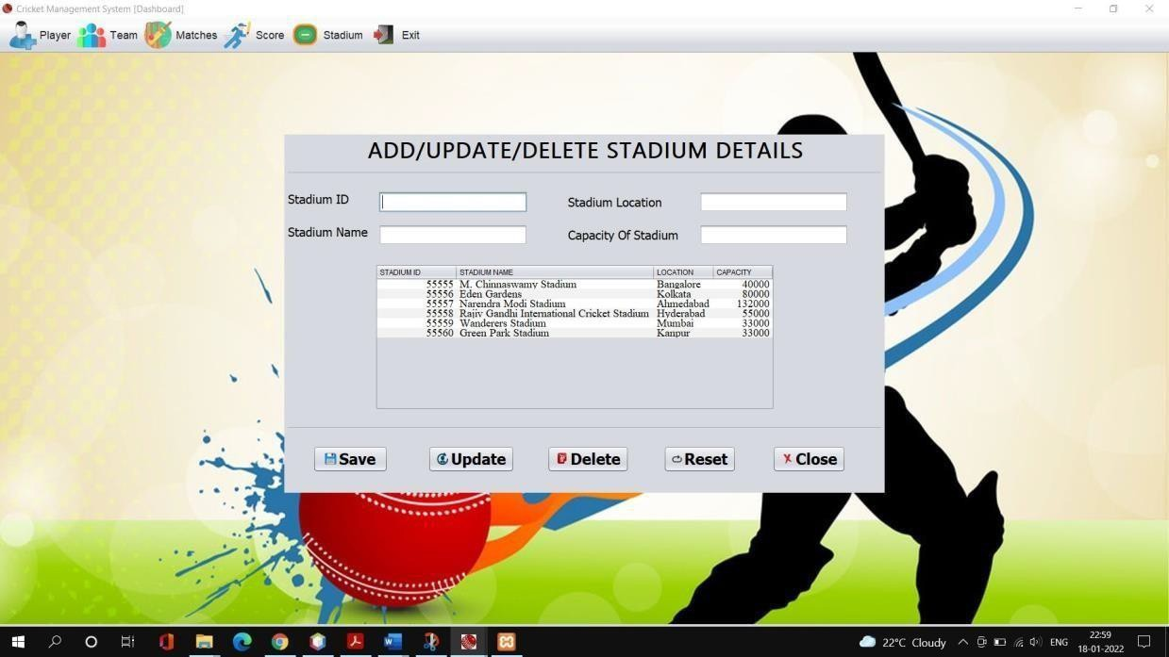
Figure 7.13 Add/ Update/ Delete Stadium details
In the above Figure 7.13, It shows stadium window which allows admin to add a new stadiumand can also update or delete the stadium details.

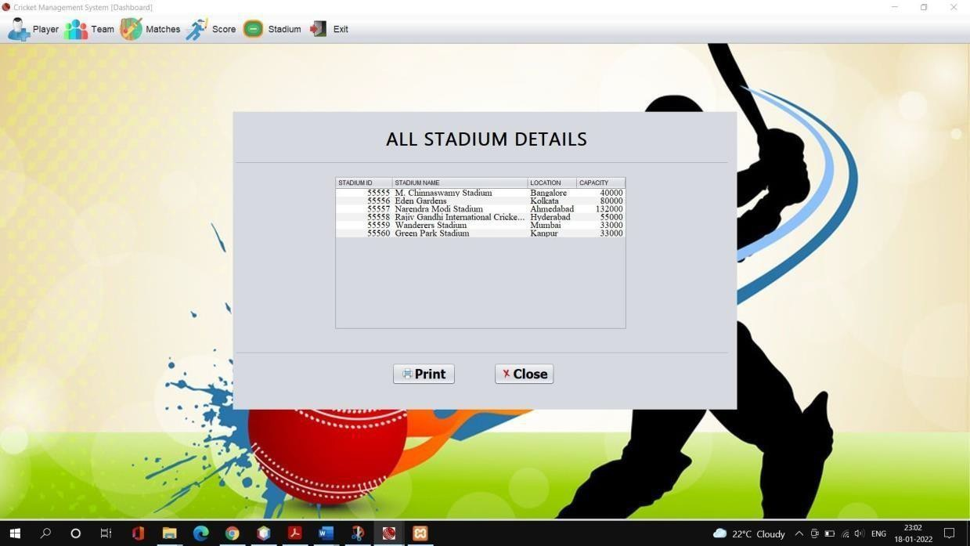
Figure 7.14 Stadium details
In the above Figure 7.14, It shows stadium details window which allows admin to print thedetails of stadium from the connected printer or just can save as pdf document.

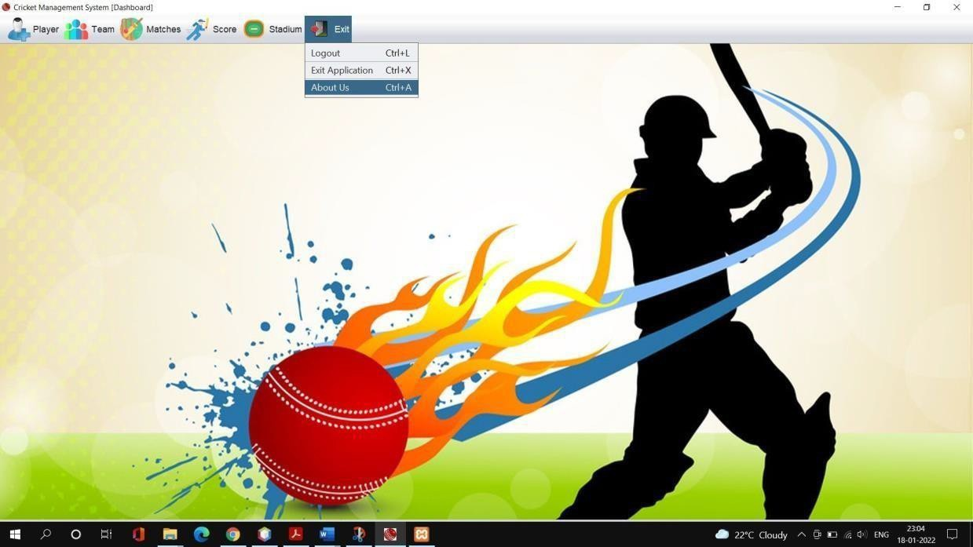

Figure 7.15 Exit menu
In the above Figure 7.15, It show the exit menu which has got Logout, Exit Application andAbout Us

CHAPTER 8

Attach the Real Time project certificate / Online course certificate

